StyleCop and FxCop

# StyleCop

StyleCop checks C# code for conformance to StyleCop's recommended coding styles and a subset of Microsoft's .NET Framework Design Guidelines. The rules are classified into the following categories:

* Documentation
* Layout
* Maintainability
* Naming
* Ordering
* Readability
* Spacing

Documentation for the latest version (.NET Core 2 / VS 2017) can be found on GitHub:

<https://github.com/DotNetAnalyzers/StyleCopAnalyzers>

## Setup

**StyleCop is installed on a per-project basis.** There is a VS extension that you can install if you like, but it’s not required with VS 2017. The extension gets you a few extra context menu items and such, so that you can run StyleCop without kicking off a full build.

You merely add StyleCop to your project as a NuGet package, and that’s it. You need to install StyleCop.Analyzers:

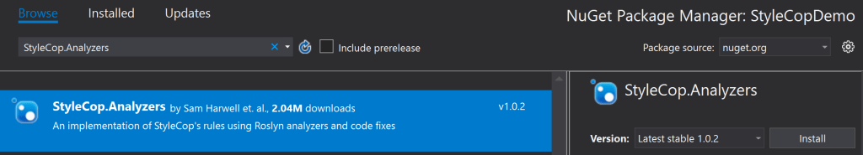

Once this is added, all you have to do is re-build your project and they’ll show up as warnings in the Error List window:

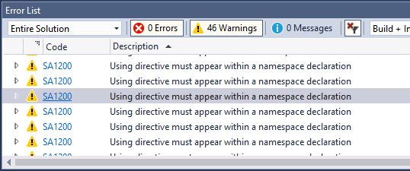

So, you’ll want to configure the rules, because a lot of them feel a little pointless, and some of them are directly OPPOSITE of what people normally do.

## Setting up stylecop.json

You’ll need to set up a stylecop.json file, and this file should be checked in with the other files for your project. For VS 2017 this is a two-step process.

Step 1: The easiest way to add a stylecop.json configuration file to a new project is using a code fix provided by the project. To invoke the code fix, open any file where SA1633 is reported (The file header is missing or not located at the top of the file.) and press Ctrl+. to bring up the Quick Fix menu. From the menu, select Add StyleCop settings file to the project.

Or, you can create a new stylecop.json file in the root of your project folder and copy-paste this text:

{

  "$schema": "https://raw.githubusercontent.com/DotNetAnalyzers/StyleCopAnalyzers/master/StyleCop.Analyzers/StyleCop.Analyzers/Settings/stylecop.schema.json",

  "settings": {

    "documentationRules": {

      "companyName": "PlaceholderCompany"

    }

  }

}

Step 2: Once you have that stylecop.json added to your project and saved, go to the properties for the file:

1. Open Solution Explorer
2. Click the file
3. Properties (Alt+Enter)

Set the build action to C# analyzer additional file. If you’re not using .NET Core then set the type to Additional file.

## Configuring rule options in stylecop.json

Once you have stylecop.json set up, all you have to do is open it and start typing, and the intelliSense™ will kick in. Everything goes under the “settings” property.

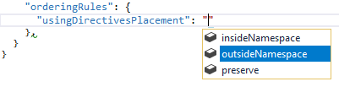

## Disabling rules

Click on an error in the errors window. That will take you to the offending line of code. Now press Ctrl+. to get the Quick Fix menu and then select Supress SAxxxx.

You have a couple options:

This will create a file called GlobalSuppressions.cs, which has a bunch of assembly-level attributes.

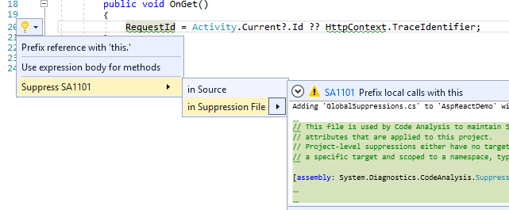

You will have to modify the rule suppression. By default, Vs will add the rule to be specific to that single offense in that single class, on that single line.

* To apply the rule for the whole file, use a #pragma instead of using GlobalSuppressions.cs
* To make the rule apply for that class only, set Scope to “type”, and modify the Target to refer to a class name.
* To make a rule apply for the entire project, erase the Scope parameter and the Target parameter.

## Treating warnings as errors

I got this working, but it’s not recognizing my config, so it’s treating all errors as warnings regardless of what’s been suppressed or not.

You’ll need to install another NuGet package:

StyleCop.MSBuild

Now you need to edit your .csproj file (so unload it, then open it in an editor). Add this to your Project/PropertyGroup element:

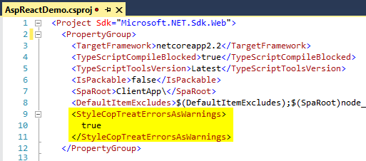

NOTE: the newer StyleCop built on the Roslyn analyzer will ignore generated files for you. There are a lot of blog-posts that’ll warn you about generated files, but you can ignore them.

When you build, you’ll see this (which is only sort of helpful. Ugh…):

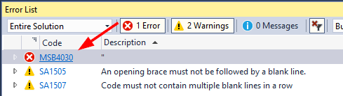

Clicking the error will take you to a cryptic config file (StyleCop.MSBuild.targets)